AfricaAI: Runbook – SHFEMVD – SHFE
Summary | We would like the tabular data corresponding to SHFE Member Volume data described below.
Source name | Shanghai Futures Exchange - SHFE
Link to the source | https://tsite.shfe.com.cn/eng/reports/statistical/daily/  https://www.shfe.com.cn/eng/reports/StatisticalData/DailyData/
Dataset name | SHFE Member Volume Data- SHFEMVD
Frequency | Daily
SLA | Check for data availability each business day.
Expected Time | Before 08:00 AM UTC

Instructions:
1. NB! This data should be processed only via your AWS workspace.
Go to the link: https://tsite.shfe.com.cn/eng/reports/statistical/daily/
https://www.shfe.com.cn/eng/reports/StatisticalData/DailyData/
Set up the Daily ranking statistical data as shown on screenshot below:
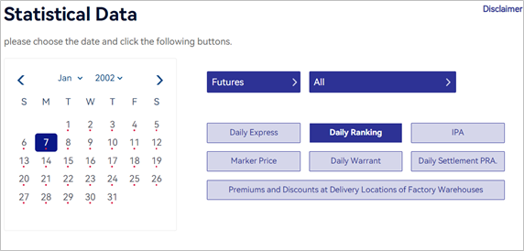
1. Find the export data to csv (“Export excel”) button at the bottom of the page with tables:
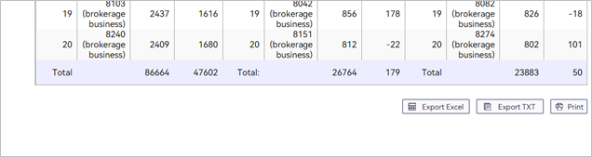
1. Save uploaded file to folder. Resave the file in the CSV UTF-8 format.
1. Open “Query_v3.1.xlsx” file.
Select any cell in the table, then in the menu at the top of the file, click on "Query":
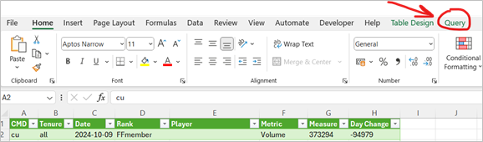
1. In the menu that opens, click "Edit":
1. The editor page will open. Find "Data source settings" in the menu at the top and click:
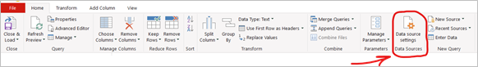
1. In the window that opens, click on the "Change source" button:
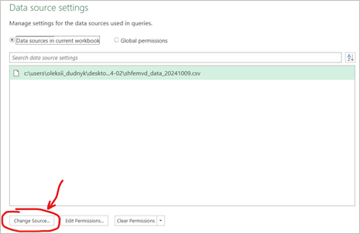
1. In the window that appears, click the "Browse" button and select the previously downloaded source file (select file and click “Import” button), then click Ok:
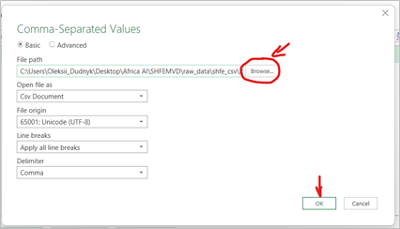
1. Then click “Close”:
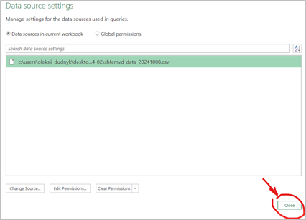
1. In the menu at the top of the window, click "Close and Load":
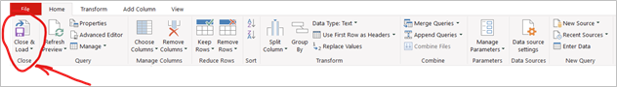
1. The data in the table should update automatically in 10-15 seconds. If the data has not updated after the specified time, click on the "Queries" tab and click on the "Refresh" button:
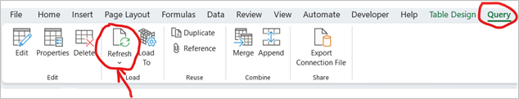
1. Copy the table from the "Query_v3.1.xlsx" file to a new file and save it in the csv format.
2. Check that the values ​​in the csv file match the values ​​in the table in the "Query_v3.1.xlsx" file.
Note that the Date column will be empty. It is necessary to copy the date value from the source file (from Date) to all rows of the new file (column Date):

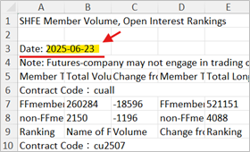
The date format for the values ​​in the "Date" column must be mm/dd/yyyy. Make sure the values ​​are in the correct format. If not, change the format to the required one.
When new data appears, add rows with new data to the current file “SHFEMVD_DATA.csv” (please note that new data should be placed higher than older data).
Upload the csv file (without archiving) to SFTP folders:
SFTP folders:
Dev env: dfac-datadev-africaai/Tabular_Manual/SHFE/SHFEMVD/
dfac-datadev-africaai-tm/Tabular_Manual/SHFE/SHFEMVD/
dfac-common-africaai/tng/shfemembervolumedata/shfe/
ProdVal: dfac-prodval-africaai/tng/shfemembervolumedata/shfe/
PRODHA env: dfac-prodha-africaai-tm/Tabular_Manual/SHFE/SHFEMVD/

dfac-prodha-africaai/tng/shfemembervolumedata/shfe/

Please inform the DataOps and DataEngineering teams in case of changes in the source tables.

Important! Field titles should match the examples and not contain extra characters or other name formats (unless the provider has added other fields in the historical data).

